Grimm & Co Access Statement

Please find information below about accessibility at Grimm & Co.

Although we are always looking to improve our access provision, our building is very old and has some limitations. The information below includes a detailed description of our space and the facilities we can currently offer.

We are committed to including all young people in all our workshops wherever possible. Please do get in touch if you think a young person hoping to attend a workshop would need anything specific from us that isn’t covered below.

Our priority is always the safety and wellbeing of young people and unfortunately there may be times when our facilities and capacity can’t adequately meet their needs. We are always looking to review and improve upon this.

If you would like any further information or have any questions, our access officer Louise Treloar would love to hear from you. You can contact them at info@grimmandco.co.uk or by calling Grimm & Co on 01709 829750. We will always try as hard as possible to address any barriers you might face if you are thinking of visiting us.

This access guide covers:

Accessibility headlines

Getting to Grimm & Co

Our building

Entrance

Inside the shop

Toilets

Visiting or coming to a workshop

Accessibility headlines

There is level access to our building and staff can meet you on arrival if needed.

We have gender neutral toilets in our shop and in the workshop space. We also have an accessible Changing Places toilet on the ground floor.

We always have First Aid assistance on site.

We welcome assistance animals and can give them water to drink.

We have an accessible lift to our first-floor workshop space and to our lower ground floor office space (for staff and volunteers).

Getting to Grimm & Co

Drop off and pick up points - If you are being dropped off or picked up, there is a layby directly outside the building.

Details on getting to Grimm & Co are available here.

Our building

Entrance

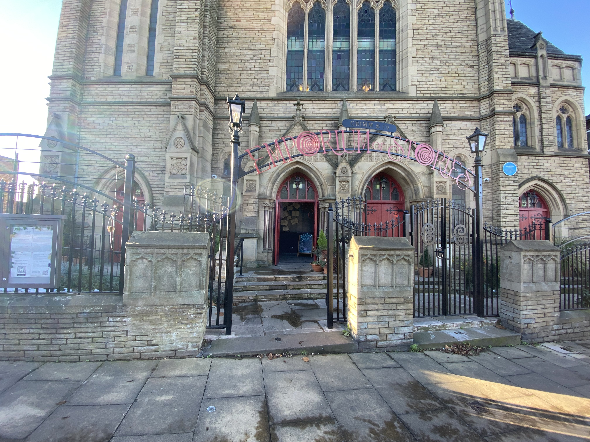
A photograph of the entrance to Grimm & Co

Grimm & Co is entered through double doors which open outwards and are propped open during the shop and cafe opening times. There is a 124cm space to get through when these doors are open. There are three steps from pavement level but there is also a paved ramp for wheelchair or buggy access on the left-hand side.

You will enter the foyer area with books on either side that are free to take away.

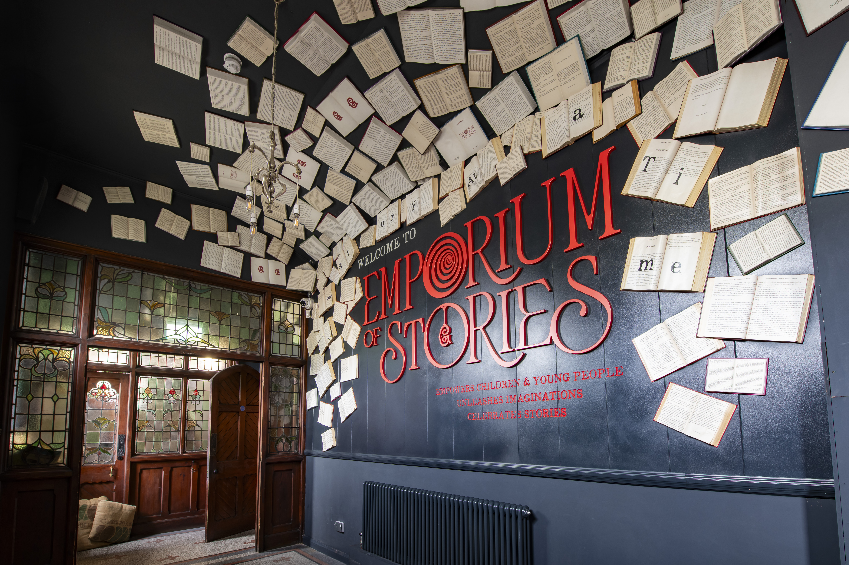

Entrance to the shop is on the right- or left-hand side of the foyer through a door measuring 94cm. The door may be closed to control the temperature in the shop but may be opened easily. The doors may slam in windy conditions.

There are permanent ramps from these doors into the shop area with a handrail on either side.

Inside the shop

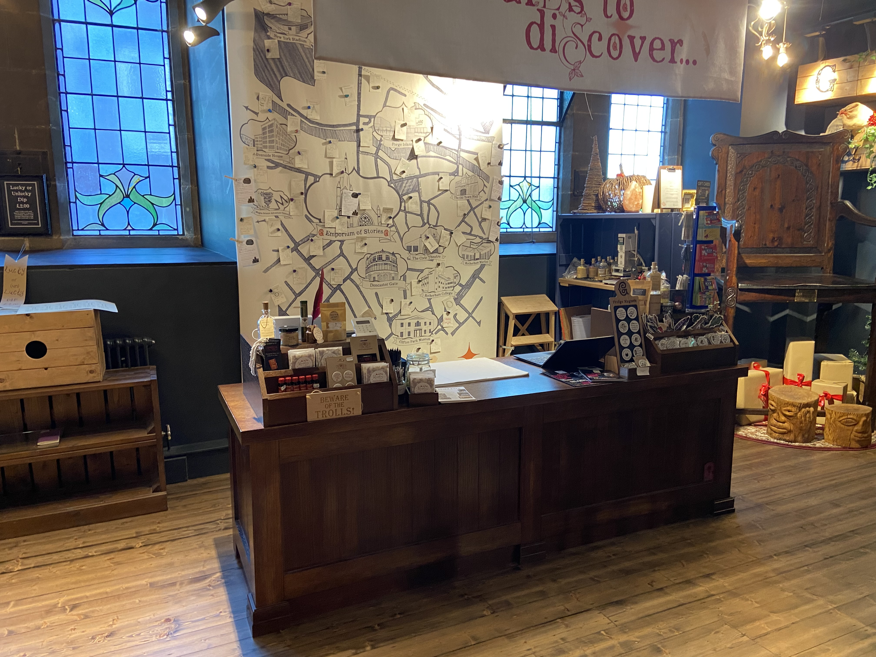
A photograph of the shop counter

When you enter the shop, you will see the shop counter to the right-hand side. Our staff will be in the shop area or behind the counter in case of queries.

Our shop contains a number of stands and tables displaying our products. There is space between these for wheelchairs and buggies to pass through, and a central area large enough for wheelchairs and buggies to turn.

There is music playing in the shop area. These are woodland soundscapes that may include birdsong.

Ear defenders and stim toys are available in the shop and cafe area if required. Please ask staff if these are required.

Certain areas of our shop smell strongly of fragrance due to the products we make and sell here. These are mainly located in the blue Apothecary area.

We welcome assistance animals and can give them water to drink. The nearest grassed area is outside the Minster located around 0.2 miles away. There is also a safe open area at the side of Rotherham Sight and Sound located 80 yards away on Ship Hill.

There is a relief area for assistance animals nearby in Clifton Park (0.7 miles away). The route to the park is down the High Street in Rotherham and then up an inclined pavement with a few side roads to cross. At the top of the street there is a main road to cross before entering the park.

The shop floor is level access.

The main area of the Feastery cafe is level access. The far end of the cafe is known as Cliffhanger Castle. There is a single step into this area. There is also a permanent ramp into the Cliffhanger Castle area which has a handrail on each side. This is 144cm wide.

There is a ceiling heater in the shop and cafe to control the temperature. Depending on the outside temperature the area may feel too hot or cold. Staff are happy to adjust the temperature where possible and we have blankets in the cafe area if you are a little chilly.

Our shop counter is at an accessible height for wheelchair users. It measures 65cm high.

The Feastery counter is 77cm high.
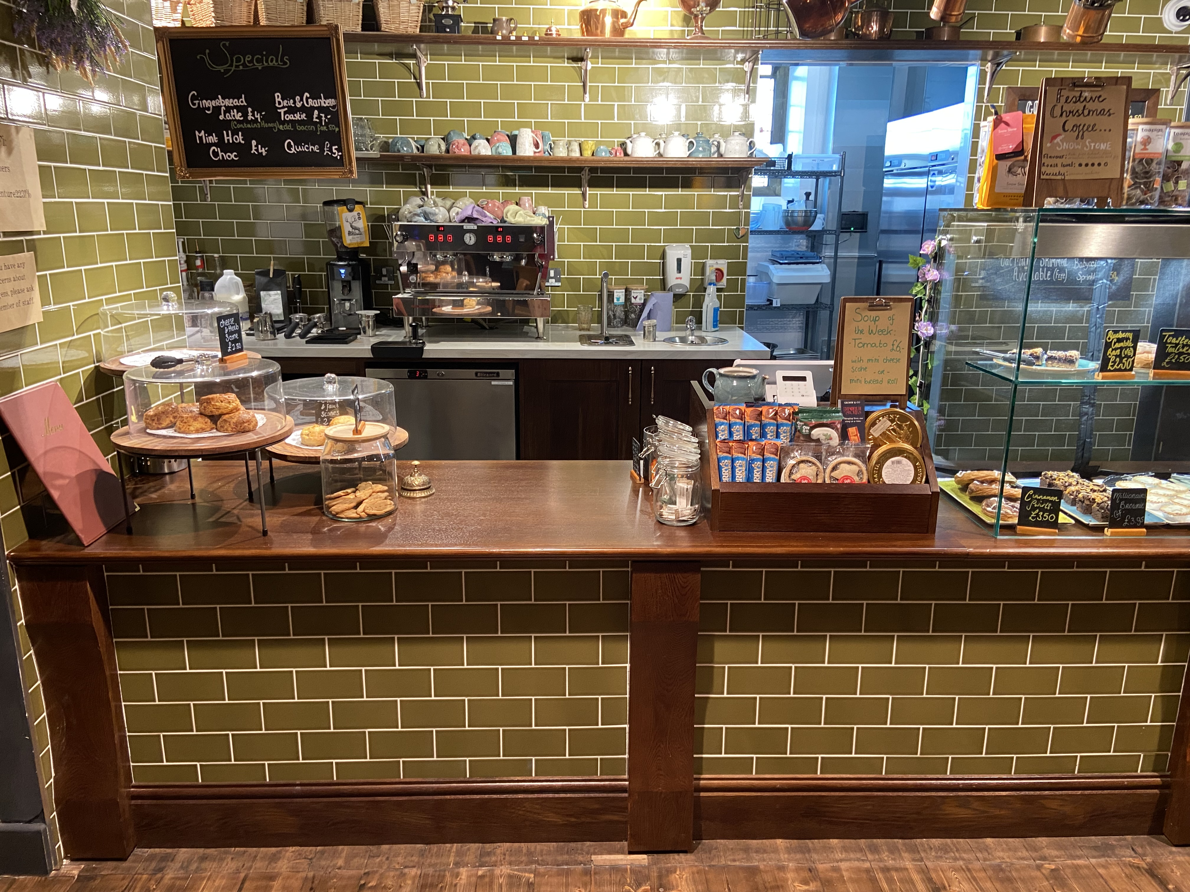

There is a lift with level access on the ground floor. This can be used to gain access to our first floor workshop space or down to the Lower Ground Floor (for use by staff and volunteers). This is through a double door which is only accessed with staff when on a workshop session.

Toilets

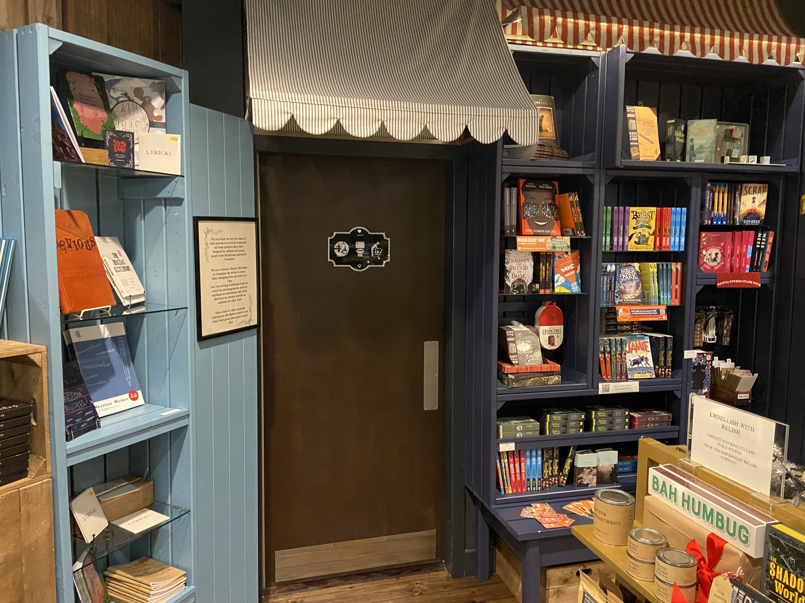

Entry to the ground floor toilets is on the left-hand side of the shop approximately halfway into the building between two blue shelving units. There is a canopy over the door and the door measures 90cm.

Once through the door there are three gender neutral toilets with level access on the right-hand side. The doors measure 80cm and opens outwards. The cubicles contain a toilet, sink, sanitary bin, toilet roll holders on the left-hand side, hand dryers and hand paper towels above a paper bin.

On the left-hand side as you enter the toilets, there is a Changing Places toilet and Baby Change area. This is through a door that measures 90cm.

The Baby change area contains a baby changing fold-down table, a sink, nappy bin and small seat.

There is then a further door into the Changing Places toilet. Both doors should be closed when using the Changing Places toilet. The door may be locked – a Radar key is available at the shop counter if required.

The Changing Places toilet has a toilet on the left-hand side with two fold down handles. There are shelves and hooks on the wall and a sanitary bin. Further along the left-hand side there is an adjustable sink, screen and paper towel dispenser.

An emergency call button can be activated by pulling the red string on the left-hand side of the toilet. The alarm sounds in the shop area where staff are always present.

The room also contains a changing bed with support rails, a shower and a full hoist.

You can also use this location map to find other Changing Places toilet: http://changingplaces.uktoiletmap.org/

Grimm & Co has toilets on the first-floor, with gender neutral cubicles and a single wheelchair accessible toilet for anyone attending workshop sessions.

Visiting or coming to a workshop

Our workshops take place upstairs in one of our Writer’s Pads. This space is usually reached by using a flight of stairs, but you can also use our lift to get there.

If you or anyone you know are anxious or nervous about visiting Grimm & Co and attending one of our workshops, we can arrange a pre-visit to show you around our space in a way that helps you feel comfortable. These visits could also be run as touch tours. If you would like to have a pre-visit please contact our access officer and they will be able to help you arrange this.

Space is provided on workshop registration forms for you to give details of any access needs that children and young people attending workshops may have.

We have breakout spaces available for those that need a bit of time out during our workshops.

There is a prayer room available for anyone attending a workshop with us.

We have ear defenders available for anyone who needs them, and we also have a small collection of sensory/stim toys available for use.

Each Writer’s Pad space has an induction loop.

Food and drinks are served during workshops. This is normally water/squash and a choice of biscuit or fruit. Biscuits are always nut free. There is space on registration forms to note down any food allergies attendees might have and you can also discuss this with us in more detail by email or telephone.

Young people are only able to bring their own food and drink to workshops if it is part of a special diet.

Use of prescription medicines is allowed if you share details of this with us in advance. There is space on the workshop registration form to let us know about this, and you can discuss it with us in more detail by email or telephone.

